**OPENSTAX MICROBIOLOGY TEST BANK OpenStax Microbiology THIS TEST BANK COVERS ALL CHAPTERS**

**1-26 OF THE BOOK, Answered**

**Chapter 1: An Invisible World**

* **= Correct answer Multiple Choice**

1. Which of the following is true of the microbial world?
   1. All microbes are harmful.
   2. Humans could survive without microbes.
   3. Many microbes are helpful.*
   4. Most microbes are pathogenic.

Difficulty: Easy

ASM Standard: 23, 24

1. Which of the following is when humans first suspected the existence of microbes?
   1. during the Industrial Revolution
   2. in prehistoric times*
   3. in the last century
   4. within the last 500 years

Difficulty: Easy ASM Standard: 23

1. Which individual first observed unicellular organisms, which he called “animalcules,” using a microscope he developed?
   1. Robert Koch
   2. Louis Pasteur
   3. Thucydides
   4. Antonie van Leeuwenhoek*

Difficulty: Easy ASM Standard: 6

1. To reduce the risk of open flame from Bunsen burners, microbiologists are increasingly using which of the following devices for easy, rapid benchtop sterilization of small pieces of equipment?
   1. autoclaves
   2. ethylene oxide
   3. incubators
   4. microincinerators*

Difficulty: Easy ASM Standard: 36

1. The Swedish botanist known for having developed an important biological classification system is which of the following people?
   1. Ernst Haeckel
   2. Carolus Linnaeus*
   3. Louis Pasteur
   4. Robert Whittaker

Difficulty: Easy ASM Standard: N/A

1. Which kingdom was the only one found in Empire Prokaryota?
   1. Animalia
   2. Fungi
   3. Monera*
   4. Protista

Difficulty: Easy ASM Standard: N/A

1. Which are the three currently accepted domains?
   1. Archaea, Bacteria, and Eukarya*
   2. Archaea, Prokaryota, and Eukaryota
   3. Bacteria, Fungi, and Protista
   4. Bacteria, Prokaryota, and Eukarya

Difficulty: Easy ASM Standard: N/A

1. Which two taxonomic units are typically used to identify an organism when using binomial nomenclature?
   1. domain and kingdom
   2. genus and family
   3. genus and species*
   4. phylum and class

Difficulty: Easy ASM Standard: N/A

1. Which of the following is not true about the process of fermentation?
   1. It can help preserve foods, preventing spoilage.
   2. It converts sugars to organic acids, alcohols, and/or gases such as carbon dioxide.
   3. It is carried out exclusively by unicellular eukaryotes such as yeast.*
   4. It is used to make foods such as cheese and bread.

Difficulty: Moderate

ASM Standard: 11, 23, 26

1. The Romans may have reduced their risk of waterborne infectious diseases by using which of the following?
   1. a variety of pharmaceutical products
   2. aqueducts and a sewer system*
   3. prophylactic antibiotics
   4. quarantine of people with leprosy

Difficulty: Moderate ASM Standard: 23

1. For which of the following is Thucydides known?
   1. developing an effective sewer system in ancient Greece, helping to reduce levels of disease in cities
   2. observing microbes, using a microscope, for the first time, even distinguishing between bacteria and fungi
   3. proposing that disease was caused by microorganisms
   4. realizing that people who had been infected by the Athenian plague had immunity to reinfection*

Difficulty: Moderate ASM Standard: 23, 31

1. Ernst Haeckel proposed a classification system consisting of which of the following subgroups?
   1. five kingdoms
   2. four kingdoms*
   3. two domains and three kingdoms
   4. two domains and five kingdoms

Difficulty: Moderate ASM Standard: N/A

1. Viruses not included in phylogenetic trees for which of the following reasons?
   1. It is too difficult to observe their characteristics.
   2. They are acellular and nonliving.*
   3. They do not have any genes, which prevents genetic analysis.
   4. They lack a nucleus.

Difficulty: Moderate ASM Standard: 5

1. Which is the best description of the primary purpose of a phylogeny?
   1. Phylogenies show all the alterative names for each species.
   2. Phylogenies show all the common names for each species.
   3. Phylogenies show evolutionary relatedness between organisms.*
   4. Phylogenies show interactions between species in a shared habitat.

Difficulty: Moderate ASM Standard: 5

1. Current phylogenetic analyses include which of the following?
   1. information from a range of sources, including morphological, genetic, and biochemical data*
   2. information on visible similarities only
   3. information regarding how to classify organisms on the basis ofexternal morphological characteristics and visible behaviors
   4. varied morphological and structural characteristics, with preference for leaving historical classifications to prevent confusion

Difficulty: Moderate ASM Standard: 5

1. Diatoms are classified within which of the following domains?
   1. Archaea
   2. Bacteria
   3. Eukarya*
   4. Prokaryota

Difficulty: Moderate ASM Standard: N/A

1. Horizontal gene transfer involves which of the following?
   1. any transfer of genes in a laboratory setting
   2. the transfer of genes from a virus to a bacterium or vice versa but not any other form of gene transfer
   3. the transfer of genes from one individual to another, including from one species to another, but not from parent to offspring*
   4. the transfer of genes from parent to offspring

Difficulty: Moderate ASM Standard: 2, 4

1. Bacteria are generally identified to species by using which of the following?
   1. a combination of genetic, biochemical, and microscopic approaches*
   2. a combination of microscopic and physiological approaches, but not genetics
   3. primarily characteristics such as motility that can be visualized using microscopy
   4. primarily morphological characteristics of individual cells

Difficulty: Moderate ASM Standard: 34, 36

1. For taxonomic classification of microbes, serological tests typically are used todo which of the following?
   1. determine complete genome sequences for microbes
   2. identify proteins on the basis of their reaction with specific antibodies*
   3. run analyses to identify whether particular genes are present
   4. visualize microbial external morphology

Difficulty: Moderate ASM Standard: 34, 36

1. Which of the following is true of bacterial strains?
   1. They are closely related subtypes within a bacterial species that may or may not have similar properties.*
   2. They are informal bacterial groupings used for medical distinctions but not recognized for classification purposes.
   3. They are more distantly related to each other than are members of a single bacterial species.
   4. They are very similar bacteria with almost identical properties.

Difficulty: Moderate ASM Standard: 5

1. *Bergey’s Manual of Systematic Bacteriology* is used primarily as which of the following?
   1. a guide to bacterial shapes
   2. a historical account of changes in classification techniques
   3. a list and characterization of all known medically relevant microbes
   4. a reference for bacterial classification*

Difficulty: Moderate ASM Standard: 34

1. Which of the following indicates how bacteria and viruses typically compare in size?
   1. Bacteria are indistinguishable from viruses.
   2. Bacteria are much larger than viruses.*
   3. Bacteria are much smaller than viruses.
   4. Bacteria are similar in size to viruses.

Difficulty: Easy ASM Standard: N/A

1. Viruses are classified as which of the following?
   1. Archaea
   2. Bacteria
   3. Eukarya
   4. distinct from the three-domain system*

ASM Standard: 4

1. Which of the following is not a curved bacterial shape?
   1. bacillus*
   2. spirillum
   3. spirochete
   4. vibrio

Difficulty: Easy ASM Standard: 34

1. Based just on the name, which of the following groups of bacteria contains entirely species that consume organic compounds for food?
   1. cyanobacteria
   2. green nonsulfur bacteria
   3. green sulfur bacteria
   4. nonphotosynthetic bacteria*

Difficulty: Moderate

ASM Standard: 11, 13, 20

1. Chitin cell walls are characteristic of which taxonomic group?
   1. algae
   2. archaea
   3. bacteria
   4. fungi*

Difficulty: Moderate ASM Standard: 20

1. Yeasts are which of the following?
   1. a type of algae
   2. a type of protist
   3. any unicellular microbe
   4. unicellular fungi*

Difficulty: Moderate ASM Standard: 20

1. The cell walls of archaeans often contain which of the following substances?
   1. cellulose
   2. chitin
   3. peptidoglycan
   4. pseudopeptidoglycan*

Difficulty: Moderate ASM Standard: 20

1. Which of the following is not true of archaeans?
   1. Some species live on the human body.
   2. They are genetically distinct from bacteria.
   3. They are only found in extreme environments.*
   4. They have substantial metabolic differences from bacteria.

Difficulty: Difficult ASM Standard: 20

1. Which of the following is not true of algae?
   1. All the algae are classified together in one similar group closely related togreen plants.*
2. Ingredients made from algae, including carrageenan, are used in food products.
3. They are being used to develop biofuels.
4. They are sometimes multicellular.

Difficulty: Moderate

ASM Standard: 20, 23, 26

1. Oral thrush is caused by which type of organism?
   1. algae
   2. bacteria
   3. fungi*
   4. protists

Difficulty: Moderate ASM Standard: 23

1. Mycotoxins are produced by which type of organism?
   1. archaeans
   2. heterotrophic protists
   3. molds*
   4. protozoans

Difficulty: Moderate ASM Standard: 23

1. Which of the following is not a common use of fungi?
   1. the production of alcoholic beverages
   2. the production of carrageenan*
   3. the production of cyclosporine
   4. the production of penicillin

ASM Standard: 20, 23, 26

1. The guinea worm is best described as which of the following?
   1. a helminthic parasite transmitted by consuming contaminated water*

B. a type of mold that grows into a worm-like shape and produces antimicrobial chemicals

1. a type of protist found in water that has not been properly treated
2. a type of protozoan that is unusual because it is multicellular

Difficulty: Moderate ASM Standard: 23

1. Which of the following is true of the genetics of viruses?
   1. Viruses always contain DNA and force host cells to produce RNA.
   2. Viruses always contain DNA and RNA.
   3. Viruses always contain RNA and force host cells to produce DNA.
   4. Viruses can contain either DNA or RNA, but not both.*

Difficulty: Moderate ASM Standard: N/A

# True/False

1. All organisms studied in the field of microbiology are visible only with a microscope. Answer: False

Difficulty: Easy ASM Standard: N/A

1. Older scientific names are typically derived from Latin. Answer: True

Difficulty: Easy ASM Standard: N/A

1. Animal cells are generally about the same size as bacterial cells. Answer: False

Difficulty: Easy ASM Standard: N/A

1. Researchers studying a 5300-year-old mummy discovered in the 1990s think he may have been trying to use a fungus to treat his illnesses.

Answer: True Difficulty: Easy

ASM Standard: 23, 26

1. Analyses of rRNA genes suggest that Archaea, Bacteria, and Eukarya evolved from a common ancestor.

Answer: True

Difficulty: Moderate ASM Standard: 5

1. The average size of a typical virus is approximately 100 nm. Answer: True

Difficulty: Moderate ASM Standard: N/A

1. When a scientific name is used repeatedly, both the genus and species must always be written out in full to avoid confusion.

Answer: False

Difficulty: Moderate ASM Standard: N/A

1. *Taenia saginata* is a type of fungus that causes disease. Answer: False

Difficulty: Moderate ASM Standard: 23

# Matching

1. Match each type of microbiological tool with the best definition.
   1. loop i. tool used to transfer microbes from one location to another
   2. media ii. liquid, solid, or gel that contains nutrients to aid microbial

growth

* 1. microincinerator iii. tool used to sterilize equipment
  2. Petri plate iv. container used to grow microbial cultures

Answers: A. i., B. ii., C. iii., D. iv.

Difficulty: Easy ASM Standard: 36

1. Match the bacterial shape with the illustration.

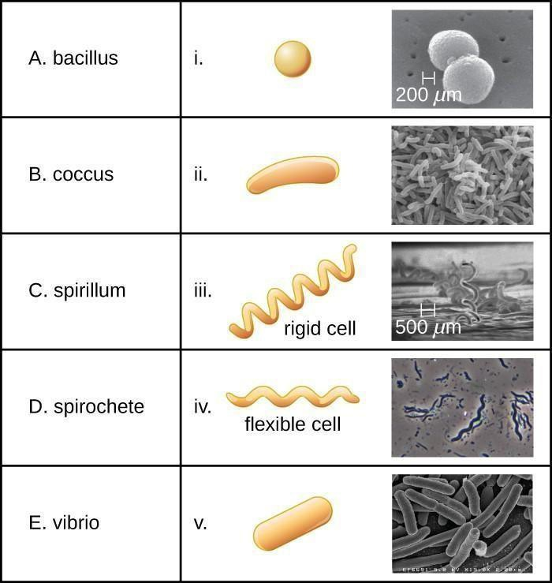

(credi t m i crograph “i ”: m odi fi cati on of w ork by Jani ce H aney Carr, C enters for D i sease C ontrol and

Prevent ion ; cred it microgra ph “iii”: mo dif icat ion of work by Ce nters for Dise ase C o ntrol an d Prevent ion)

Answers: A. v., B. i., C. iv., D. iii., E. ii.

Difficulty: Easy ASM Standard: 34

1. Match each type of microbe with the best description.
   1. algae i. a very broad, informal grouping of organisms that do not fit into

other eukaryotic kingdoms and that may be photosynthetic or nonphotosynthetic

* 1. fungi ii. a diverse, informal subgroup of organisms that may move using

cilia, flagella, or pseudopodia

* 1. protists iii. a group of photosynthetic organisms with cellulose cell walls
  2. protozoa iv. a group of nonphotosynthetic organisms that usually have cell walls

containing chitin Answers: A. iii., B. iv., C. i., D. ii.

Difficulty: Moderate ASM Standard: 2

1. Match each subfield of microbiology with the most appropriate example.
   1. bacteriology i. the study of how antibodies are released in response to a pathogen
   2. immunology ii. the study of how fungi cause disease in plants
   3. mycology iii. the study of the classification of bacilli
   4. parasitology iv. the study of how to reduce the rate of guinea worm infections
   5. protozoology v. the study of heterotrophic protists

Answers: A. iii., B. i., C. ii., D. iv., E. v.

Difficulty: Moderate ASM Standard: 23

1. Match each taxonomic group with its domain. You will use some optionsmore than once.
   1. algae i. Archaea
   2. halophiles ii. Bacteria
   3. helminths iii. Eukarya
   4. spirochetes

Answers: A. iii., B. i., C. iii., D. ii.

Difficulty: Moderate ASM Standard: 2

1. Match each causative agent with the associated classification.
   1. *Dracunculus medinensis* i. protist
   2. Ebola ii. fungus
   3. *Giardia lamblia* iii. helminth
   4. yeast iv. virus

Answers: A. iii., B. iv., C. i., D. ii.

Difficulty: Difficult ASM Standard: 23

# Fill in the Blank

1. was a Greek physician who posited that natural causes, not supernatural forces, caused disease.

Answer: Hippocrates

Difficulty: Easy ASM Standard: 23

1. is the science of identifying, naming, and classifying living organisms. Answer: Taxonomy

Difficulty: Easy ASM Standard: N/A

1. Fermentation by yeast produces ethanol and

gas. Answer: carbon dioxide

Difficulty: Moderate ASM Standard: 11, 26

1. Carl Woese and George Fox sequenced and analyzed from a wide range of organisms to build their phylogenetic tree.

Answer: rRNA (or ribosomal RNA)

Difficulty: Moderate ASM Standard: 4, 5

1. The archaebacteria are now called

. Answer: Archaea

Difficulty: Moderate ASM Standard: N/A

1. The genus of *Halobacterium salinarum* is

. Answer: *Halobacterium*

Difficulty: Easy ASM Standard: N/A

1. is the standard reference book that provides guidance onidentifying and classifying prokaryotes.

Answer: *Bergey’s Manual of Determinative Bacteriology*

Difficulty: Moderate ASM Standard: 34

1. There are nanometers in 520 meters. Answer: 520,000,000,000

Difficulty: Moderate ASM Standard: 29

58. The thermophilic genus *Thermoproteus* includes extremophiles classified in the domain

. Answer: Archaea

Difficulty: Difficult ASM Standard: 5

1. The cytoplasmic extensions used by some protists to move are called

. Answer: pseudopods

Difficulty: Moderate ASM Standard: N/A

# Short Answer

1. What is horizontal gene transfer?

Sample Answer: Horizontal gene transfer is the transfer of genetic material between two organisms that are not related as parent and offspring.

Difficulty: Easy ASM Standard: 2

1. How are newly discovered organisms named?

Sample Answer: Newly discovered organisms are usually given names that describe their characteristics and/or that honor a particular individual. The names are generally Latin, Greek, or English.

Difficulty: Easy ASM Standard: 5

1. How do protozoa move?

Sample Answer: Protozoa can move using structures such as pseudopods, flagella, and cilia. They may also be carried by the water in which they live.

Difficulty: Easy ASM Standard: N/A

1. Why are formal scientific names based on a standardized system more useful than simple names that just describe characteristics, such as “orange cat-like animal”? Sample Answer: Organisms may have similar characteristics, especially inclosely related

species. By having a formal naming system, it is possible to clearly distinguish organisms so that people around the world can identify exactly which organism is being discussed.

Difficulty: Moderate ASM Standard: N/A

1. What are at least four types of products made using fermentation?

Sample Answer: Fermentation is used to make alcoholic products, cheese, yogurts, pickled vegetables, and bread.

Difficulty: Easy

ASM Standard: 11, 23, 26

1. What is the Hippocratic Oath?

Sample Answer: The Hippocratic Oath is an oath taken by new doctors to pledge their willingness to follow certain ethical guidelines, such as avoiding causing harm to their patients.

Difficulty: Moderate ASM Standard: N/A31

66. Which famous scientist developed a vaccine for rabies? Sample Answer: Louis Pasteur developed a vaccine for rabies.

Difficulty: Moderate ASM Standard: 14, 23

1. Why is most milk pasteurized before it is sold?

Sample Answer: Pasteurization helps reduce the number of microbes associated with spoilage and disease, keeping milk safe to drink longer than if it is not pasteurized.

Difficulty: Moderate ASM Standard: 14, 23

1. What are helminths and why are they medically important?

Sample Answer: Helminths are worms. They are eukaryotes. They can be human parasites.

Difficulty: Moderate ASM Standard: 14, 23

1. Why is it often preferable to use a microincinerator rather than a Bunsen burner? Sample Answer: Bunsen burners have an open flame, whereas microincinerators do not; therefore, it is safer to use a microincinerator.

Difficulty: Moderate ASM Standard: 14, 36

1. How do scientists decide how to organize organisms in a phylogenetic tree? Sample Answer: Phylogenies show evolutionary relationships. To develop a phylogenetic tree, scientists examine a variety of characteristics, including biochemical, morphological, and genetic characteristics, to determine the most likely relationships between organisms. Genetic data are especially important in determining these relationships in modern phylogenetic trees.

Difficulty: Moderate ASM Standard: 5

1. What is the difference in how DNA is stored within the cells of prokaryotes versus eukaryotes?

Sample Answer: Eukaryotes have a true membrane-bound nucleus and prokaryotes do not.

Difficulty: Moderate ASM Standard: 9

1. What does it mean to say that some photosynthetic bacteria, including some green sulfur bacteria, are anoxygenic? Consider the word parts in “anoxygenic” if you are not sure. Sample Answer: Anoxygenic means that they do not generate oxygen.

Difficulty: Difficult ASM Standard: 11

1. Who published *Systema Naturae* and what did it present?

Sample Answer: *Systema Naturae* was published by Carolus Linnaeus to present his taxonomic system.

Difficulty: Difficult ASM Standard: N/A

1. Of the three domains, which is/are known to contain some human pathogens? Sample Answer: Bacteria and Eukarya contain some species that are human pathogens. No known archaeal pathogens have been identified.

Difficulty: Moderate ASM Standard: 23

# Brief Essay

**Essay Question Rubric RATING Failing**



**Below Average**

**Competent Advanced**

Criteria

for evaluati on

Answer does

not provide an argument. Answer contains inaccuracies. Writing is poor and contains numerous grammatical mistakes and misspellings.

Answer fails to provide examples to support an argument.

Writing is poor and grammatical errors are common.

Answer is somewhat incoherent.

Answer

provides an argument with one or two examples that support it.

Writing is acceptable for the college level but may contain one or two grammatical mistakes or misspellings.

Answer clearly

provides an argument with two or more excellent examples that support it; student makes the argument clearly and eloquently.

Answer is well organized and free of grammatical errors and misspellings.

# POINT VALUE

**0 1 2 3**

***Assume rating/grading scale for the question ranges from 0 to 3 points.***

1. Explain why some scientists think that it may be more appropriate to describe a “web of life” instead of a “tree of life.”

Answer: Student answers will vary but should include components of the following. A tree suggests straightforward pathways of evolution from one branch to another. Because horizontal gene transfer is common, this does not fully represent the complexity involved in evolution. A web would better show ways genes can be transferred from one taxonomic group to another.

Difficulty: Moderate ASM Standard: 5

1. *Halobacterium salinarum* is classified in the domain Archaea. Why does its name suggest it is a bacterium? This answer is not in the textbook chapter, so you should speculate based on your understanding of taxonomy.

Answer: Student answers will vary but should include the following. This species was identified before the domain Archaea was recognized. As a result, it was previously considered a bacterium and given a bacterial name.

Difficulty: Moderate ASM Standard: N/A

1. Consider the phylogenetic tree below. Explain how it shows the relationships between Bacteria, Archaea, and Eukarya, and their common ancestor. Of these three groups, which two are more closely related and how can you tell from the figure?

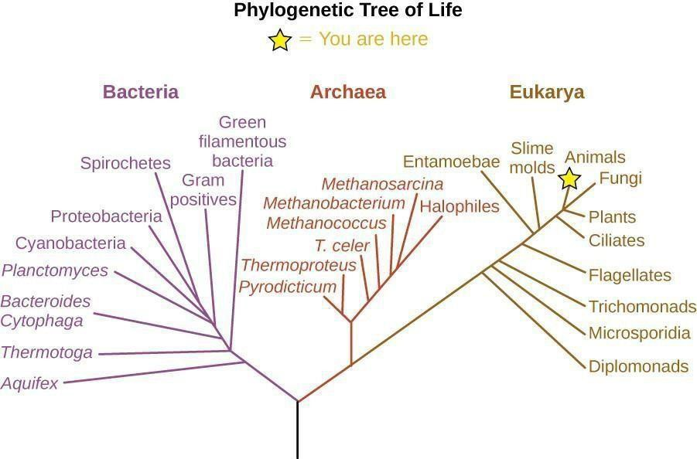

(credit: modification of work by Eric Gaba)

Answer: Student answers will vary but should include the following. The lines leading to Bacteria, Archaea, and Eukarya branch from the same root, meaning they all share a common ancestor. Archaea and Eukarya branch more closely together than either branches with

Bacteria, suggesting that they diverged from each other more recently than they diverged from a common ancestor that had previously branched from Bacteria.

Difficulty: Difficult ASM Standard: 5

1. In the textbook chapter, there is information about efforts to eradicate the guinea worm. What are some factors that have allowed these efforts to be relatively successful, with only 126 cases reported in 2014, compared with efforts to eradicate other diseases such as hantavirus, carried by rodents, and rabies, carried by a variety of wild animals? Answer: Student answers will vary but should include components of the following. Guinea worm is transmitted in contaminated water. Thus, efforts to improve water sanitation can be very effective in reducing infections. Other diseases have

different mechanisms of transmission. Diseases such as rabies are found in wild animals and it would be difficult to treat or vaccinate all infected animals.

Difficulty: Difficult

ASM Standard: 14, 23, 31

FULL CHAPTERS 1-26 DOWNLOAD VIA https://r.24zhen.com/675Os